**REPORTS**

### Creating A Report

|  |  |
| --- | --- |
| Team Id | AD47707C5D4D5109D5E480002BDB30D5 |
| Project Tittle | Build an Event Management System using salesforce |

**1. From the Reports tab, click New Report.  
2. Select the report type Occasions with Attendees for the report, and click Create.**

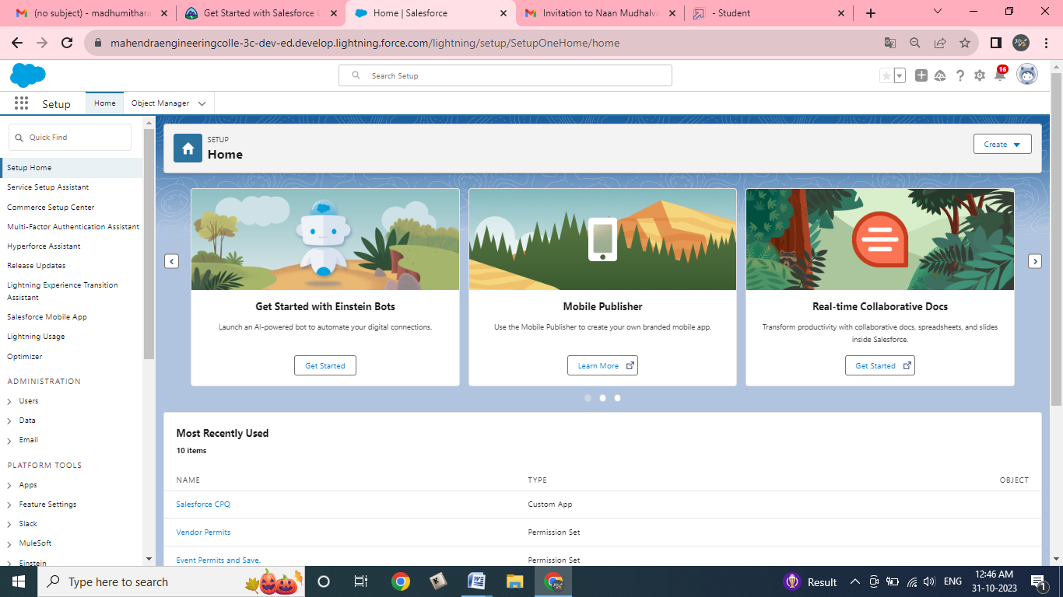

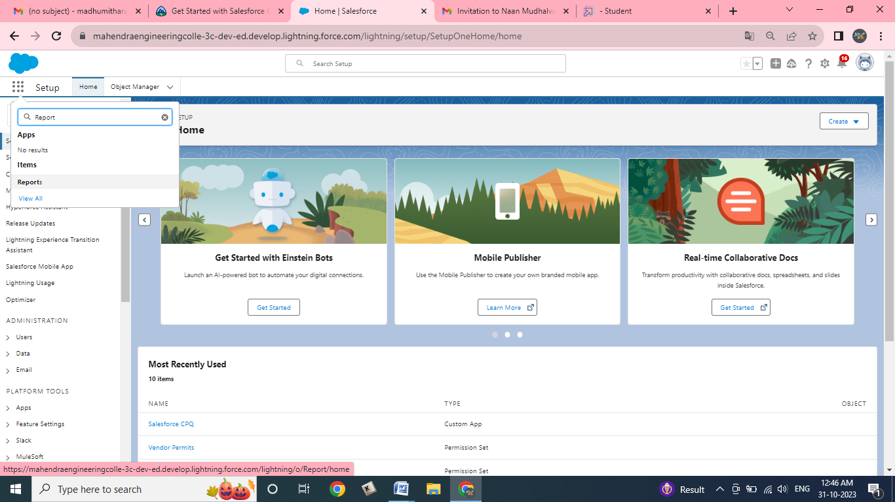3. Customize your report accordingly and include all fields,

Reports needs to be Grouped by one field. (ex - Created by )(require to enable add chart) then save(Occasions with Attendees) or run it.

